Module - 5 Network Fundamentals and Building Networks

Section 1: Multiple Choice

1. What is the primary function of a router in a computer network?

Answer:- Forwarding data packets between networks

2. What is the purpose of DHCP (Dynamic Host Configuration Protocol) in a computer network?

Answer:- Dynamically assigning IP addresses to devices

3. Which network device operates at Layer 2 (Data Link Layer) of the OSI model and forwards data packets based on MAC addresses?

Answer:- Switch

4. Which network topology connects all devices in a linear fashion, with each device connected to a central cable or backbone?

Answer:- Bus

Section 2: True or False

5. True or False: A VLAN (Virtual Local Area Network) allows network administrators to logically segment a single physical network into multiple virtual networks, each with its own broadcast domain.

Answer:- True

6. True or False: TCP (Transmission Control Protocol) is a connectionless protocol that provides reliable, ordered, and error-checked delivery of data packets over a network.

Answer:- False

7. True or False: A firewall is a hardware or software-based security system that monitors and controls incoming and outgoing network traffic based on predetermined security rules.

Answer:- True

Section 3: Short answer

8. Describe the steps involved in setting up a wireless network for a small office or home office (SOHO) environment.

Answer:-

Connect modem to router → Power on → Access router settings → Set Wi-Fi name & password → Enable WPA2/WPA3 → Enable DHCP → Update firmware → Connect & test devices.

Section 4: Practical

9. Demonstrate how to configure a router for Internet access using DHCP (Dynamic Host Configuration Protocol).

Answer:-

Connect the Hardware:

* Connect modem to router's WAN port using an Ethernet cable.
* Connect your PC/laptop to router's LAN port (or connect via Wi-Fi).

Access Router Settings:

* Open a browser and enter router IP (e.g., 192.168.0.1 or 192.168.1.1).
* Login with admin credentials (default username/password printed on router).

Enable DHCP on WAN/Internet Settings:

* Go to Internet or WAN settings.
* Set Connection Type = DHCP / Dynamic IP.
* Save/apply changes – the router will now request an IP address from your ISP automatically.

Enable DHCP on LAN (Optional but recommended):

* Go to LAN or Network Settings.
* Ensure DHCP Server = Enabled.
* Set IP address range, e.g., 192.168.1.100 to 192.168.1.200.

Save & Reboot:

* Save all settings and restart the router if prompted.

Test the Internet:

* Connect any device via Wi-Fi or LAN.
* It should automatically receive an IP and access the internet.

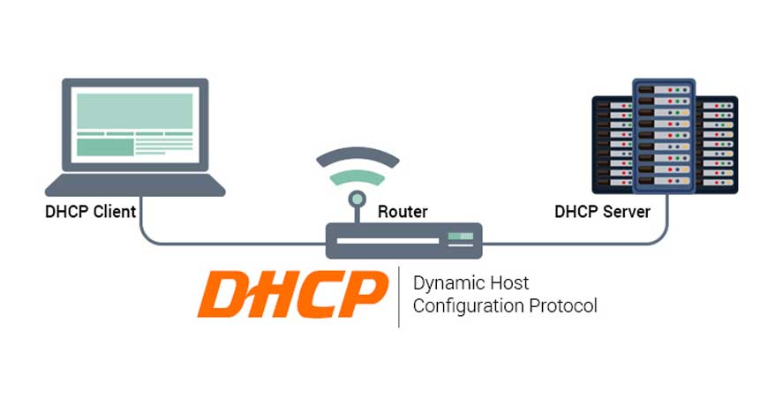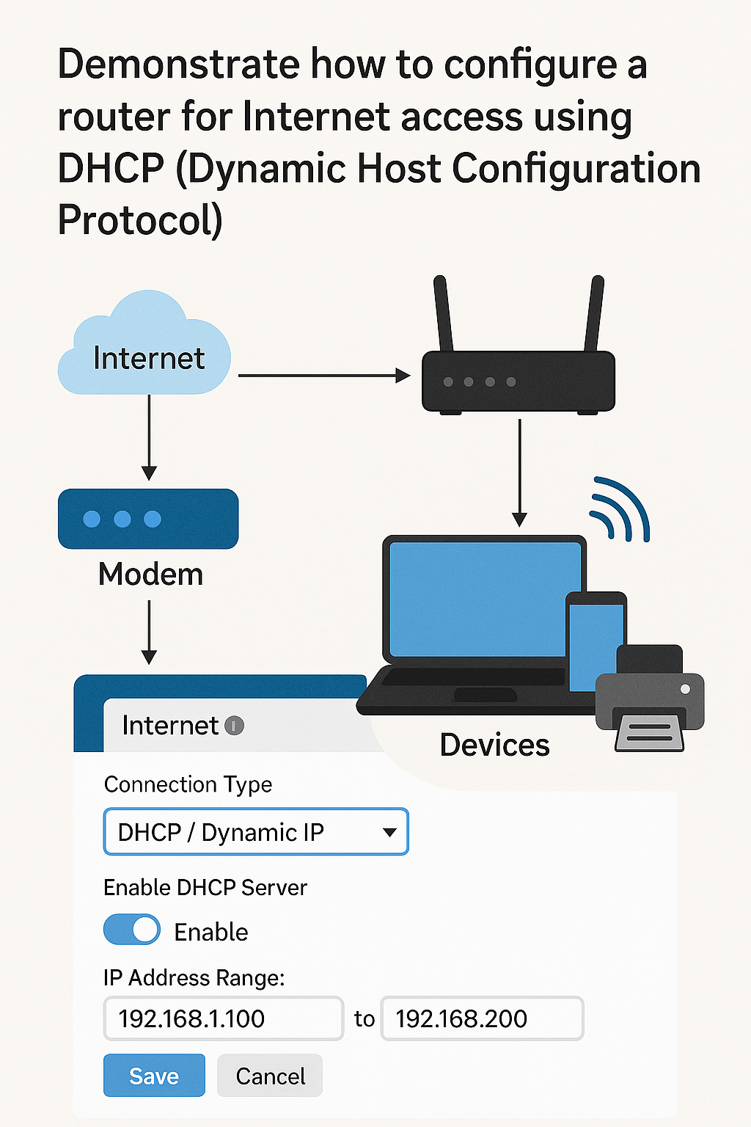

Section 5: Essay

10. Discuss the importance of network documentation in the context of building and managing networks.

Answer:-

Introduction:  
Network documentation is a detailed record of all components, configurations, connections, and procedures related to a computer network. It includes network diagrams, IP address allocations, device configurations, cabling layouts, security policies, and more. In both small and large environments, proper documentation is essential for building, maintaining, troubleshooting, and scaling networks.

Importance of Network Documentation:

1. Simplifies Network Setup & Planning

When building a network, documentation helps visualize the entire infrastructure. It ensures that IP ranges, subnets, and device roles are well planned, preventing conflicts and future issues.

2. Enhances Troubleshooting and Maintenance

In case of failure, technicians can quickly refer to documentation to identify faults and resolve them. It speeds up troubleshooting, reduces downtime, and prevents guesswork.

3. Supports Security and Compliance

Documenting firewall rules, access policies, and user roles helps enforce security. It’s also important for audits, ensuring the organization complies with industry regulations like ISO, HIPAA, or GDPR.

4. Facilitates Upgrades and Changes

When upgrading network hardware, software, or expanding infrastructure, clear documentation ensures smooth transitions without disrupting operations.

5. Assists New IT Staff or Teams

New network admins can quickly understand the structure and operation of a network by reviewing documentation. This reduces learning curves and training time.

6. Disaster Recovery Preparedness

In the event of a disaster or major failure, having complete and up-to-date documentation allows the IT team to rebuild the network quickly and accurately.

Key Components of Good Network Documentation:

* Network topology diagrams (physical and logical)
* IP address inventory
* Device names and configurations
* User access control and permissions
* Firewall and security settings
* Service providers and contact info
* Change logs and backup procedures